**Network Applications**

Had it not been of high importance, nobody would have bothered connecting computers over a network. Let's start exploring the uses of Computer Networks with some traditional usecases at companies and for individuals and then move on to the recent developments in the area of mobile users and home networking.

## Computer Networks: Business Applications

Following are some business applications of computer networks:

#### 1. Resource Sharing:

The goal is to make all programs, equipments(like printers etc), and especially data, available to anyone on the network without regard to the physical location of the resource and the user.

#### 2. Server-Client model:

One can imagine a company's information system as consisting of one or more databases and some employees who need to access it remotely. In this model, the data is stored on powerful computers called **Servers**. Often these are centrally housed and maintained by a system administrator. In contrast, the employees have simple machines, called **Clients**, on their desks, using which they access remote data.

#### 3. Communication Medium:

A computer network can provide a powerful communication medium among employees. Virtually every company that has two or more computers now has e-mail (electronic mail), which employees generally use for a great deal of daily communication

#### 4. eCommerce:

A goal that is starting to become more important in businesses is doing business with consumers over the Internet. Airlines, bookstores and music vendors have discovered that many customers like the convenience of shopping from home. This sector is expected to grow quickly in the future.

The most popular forms are listed in the below figure:

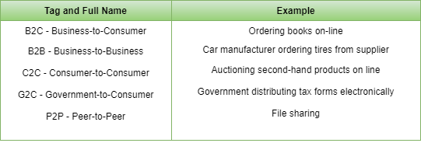

## Computer Networks: Home Applications

Some of the most important uses of the Internet for home users are as follows:

* **Access to remote information**
* **Person-to-person communication**
* **Interactive entertainment**
* **Electronic commerce**

## Computer Networks: Mobile Users

Mobile computers, such as notebook computers and Mobile phones, is one of the fastest-growing segment of the entire computer industry. Although wireless networking and mobile computing are often related, they are not identical, as the below figure shows.

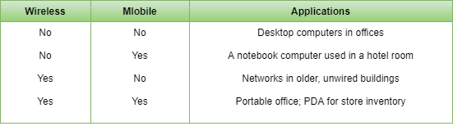

PDA(Personal Digital Assistants)